Project Development Phase
Performance Test Report – Tableau-Style Template
Implement Client Script & UI Policy (Incident)
Date | 1 October 2026
Team ID | SWTID-2026-4755
Project Name | Implement Client Script & UI Policy (Incident)
Maximum Marks | 10 Marks
1. Project-specific test context
Measure the form/list rendering and client-side control behavior under representative Incident record volumes. The Tableau reference is treated only as a report structure; this project has no Tableau dependency.
The project uses a ServiceNow Incident form and list with one High Impact Control UI Policy and three Client Scripts. The test focus below adapts the ZIP reference report type to the Incident project; it does not claim that a live execution was completed during report preparation.
2. Project metrics / equivalent parameters
S.No. | Parameter | Project-specific values / evidence
1 | Data rendered | Incident records with Impact, Urgency, Assignment group, Assigned To, and State fields.
2 | Data preparation | Use repeatable Incident fixtures with low, medium, and high Impact values plus assigned and unassigned records.
3 | Filter / control use | Compare visual field behavior with actual policy and script enforcement; UI filtering must not be mistaken for validation.
3. Test scenarios and results
Test Case ID | Scenario | Test Steps | Expected Result | Actual Result | Status
TAB-PT01 | Incident form/list at small, medium, and large record sets | Open list and form with representative fixtures; record p50/p95 response. | Records load and intended controls remain responsive. | Pending execution | Pending
TAB-PT02 | High-impact control activation | Set Impact = High and inspect Assignment group and Urgency. | Mandatory/read-only states appear without unnecessary delay. | Pending execution | Pending
TAB-PT03 | Client-side control overhead | Compare baseline form open with controls active. | Client rules remain lightweight and do not create repeated actions. | Pending execution | Pending
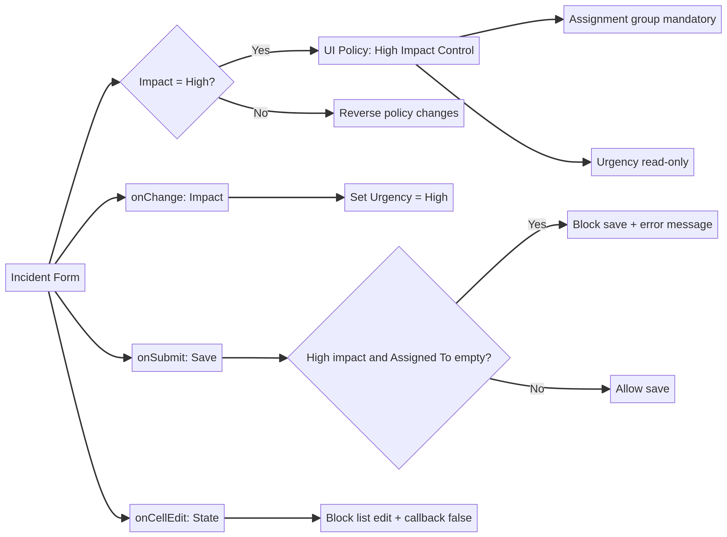
Original project-specific visual created for this Incident report.
4. Interpretation and evidence note
Performance evidence should record dataset size, browser, timestamp, p50/p95 response, error count, and whether the expected field state was reached.
5. Execution status
Status at report preparation: Pending execution in the target ServiceNow instance. The source project PDF defines the configuration and expected behavior, but does not include live screenshots, response-time logs, or execution timestamps. Record those artifacts against each test case before final sign-off.
6. Conclusion
This report provides a project-specific Phase 5 testing baseline for Implement Client Script & UI Policy (Incident). The selected scenarios verify conditional field behavior, urgency automation, save-time validation, list-edit protection, and form-based updates while preserving the traceability expected in the supplied reference reports.

